NAME- Priti yadav

ROLL NO-106

COURSE-B.SC. IT

Practical 2: Study of Data Manipulation Language Statement A) Insert the following records in above created table

EMP TABLE

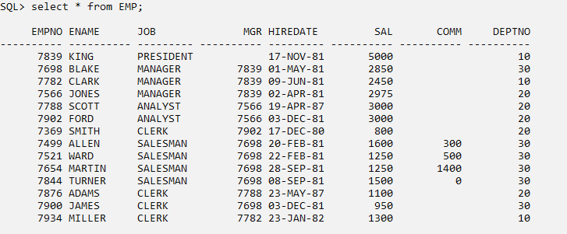

DEPT TABLE

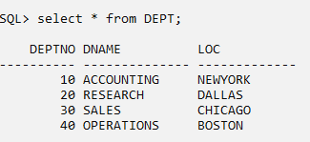

B) Update and Delete Queries

1) Update the salary of employees working as CLERK by 500.

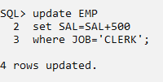

2) Update the manager of James as CLARK. 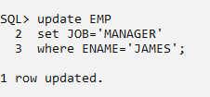

3) Change the role of Miller as MANAGER.

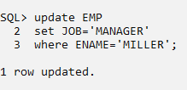

4) Delete the records of Manager

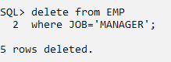

5) Delete the records when salary is greater than 1000.

